BIO-DATA
Name: Tanmoy Sarkar 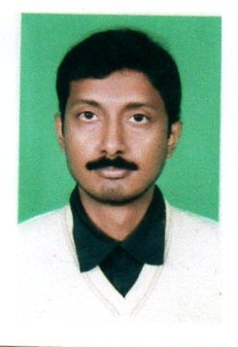
Father Name: Let Tusta Sarkar
Date of Birth: 09/07/1981
Contract No.: 9832498912
Email ID: tanmoysarkar1981@gmail.com
Date of Joining: 15th JAN 2012

Permanent Address:
Vill: Debinagar
P.O.: Debinagar
P.S.: Raiganj
Dist.: `Uttar Dinajpur
Pin: 733123
Academic Qualification:
Examination | Board/University | Subject | Passing Year | Division
Madhyamik | WBBSE | All | 1998 | 2nd
Higher Secondary | WBCHSE | His, Geo, Pol Sc, Eco | 2000 | 2nd
B.A | NBU | Phil(H), Hist, Pols, Beng, Eng | 2003 | 2nd
M.A | NBU | Philosophy | 2005 | 1st
B.Ed | GBU | Philosophy, Work Education | 2011 | 2nd

Personal Details:
Nationality : Indian
Caste : SC
Religion : Hindu
Married Status : Married
Extra Qualification : Ph.D (Persuing)
Whether qualified NET/SET : SET (2018)

